Instructions to prepare a Two Pages Abstract for the  
International Association of Maritime Universities Conference IAMUC 2018

First A. Author*, Second B. Author† and Third C. Author†

Barcelona School of Nautical Studies (FNB/UPC-BarcelonaTech)

Universitat Politècnica de Catalunya – BarcelonaTech

Pla de Plau, 18, 08003 Barcelona, Spain

e-mail: congreso@cimne.upc.edu, web page: http://www.fnb.upc.edu

† International Center for Numerical Methods in Engineering (CIMNE)

Universitat Politècnica de Catalunya - BarcelonaTech

Campus Nord UPC, 08034 Barcelona, Spain

e-mail: congreso@cimne.upc.edu, web page: [http://www.cimne.com](http://www.cimne.com/)

**Keywords:** IAMU 2018, two-pages abstract, Barcelona.

# heading

People interested in submitting a contribution to **IAMUC 2018** are requested to submit electronically a two-pages Abstract no later than **March 12, 2018**. For each abstract submitted, one thematic area from the list proposed must be specified during the abstract submission. The Scientific Committee reserves the right to assign thematic categories as necessary. All abstracts will be subjected to peer-review, coordinated by the Scientific Committee.

## Subheading

Abstracts should briefly outline the main features, results and conclusions as well as their general significance, and contain relevant references. The Abstract has to be written in English with Times-Roman letters. The Abstract should not exceed two pages. The Abstract must contain the full name and full address of author/s. In the case of joint authorships, the name of the author who will actually present it at the Conference should be indicated with asterisk. Contributions can only be accepted on the understanding that they will be presented at the Conference. Figures and tables: include the figures and tables precisely in the place you want them.

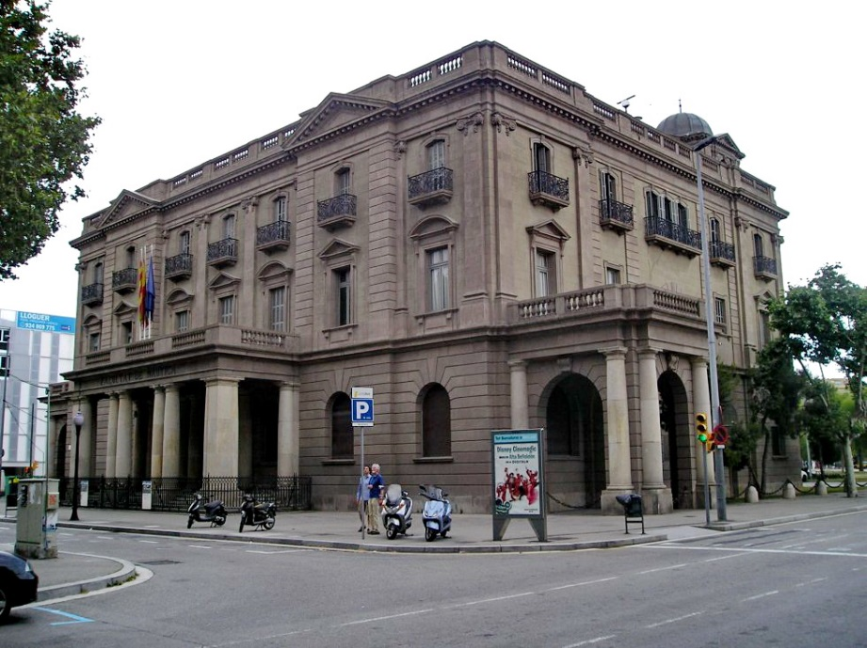

Figure 1. Barcelona School of Nautical Studies.

Table 1. Barcelona School of Nautical Studies.

|  |  |  |  |
| --- | --- | --- | --- |
|  |  |  |  |
|  |  |  |  |
|  |  |  |  |

A displayed equation is numbered, using Arabic numbers in parentheses. It should be centered, leaving a 6pt space above and below to separate it from the surrounding text. The following example is a single line equation:

|  |  |
| --- | --- |
| Ax = b | (1) |

The Abstract should be written following the format of the macros for submission that can be found at <http://congress.cimne.com/Iamu2018/frontal/Autor.asp> They must be translated to Portable Document Format (PDF) before submission through the Conference site.

## Subheading

The book of Abstract will have assigned International Standard Book Number (ISBN) as a unique numeric commercial book identifier. During the abstract submission, the authors should indicate if **they want their abstracts to be selected for the Conference Proceedings.** The Scientific Committee will make the final decision on the selection of the contributions for the **Conference Proceedings.** Instruction to prepare the full paper will be sent together with the notification of acceptance of the abstract submitted. (**9 April 2018**) Full paper will be requested by **1st June 2018.** The **Conference Proceedings***(including full papers only)* will be edited electronically and will be submitted for indexation in the Conference Proceedings Citation Index – ISI Web of Knowledge (Thomson Reuters) and in SCOPUS database.

references

1. E. Oñate and M. Cervera, “Derivation of thin plate bending elements with one degree of freedom per node”, Engng. Comput., Vol. 10, pp. 543561, (1993).
2. O.C. Zienkiewicz and R.C. Taylor, The finite element method, 4th Edition, Vol. 1, McGraw Hill, 1989.

For any further request, please contact the Secretariat:

CIMNE Congress Bureau

Campus Nord UPC Edifici C3

Zona Comercial Jordi Girona, 1-3

08034 Barcelona Spain www.cimne.com

**Tel:** +34 93 405 46 96

**Fax:** +34 93 205 83 47

**E-mail:** [iamu2018@cimne.upc.edu](mailto:iamu2018@cimne.upc.edu)