Guidelines to format papers for Form and Force 2019

Corresponding AUTHOR*, Forename B. SURNAMEa, Another AUTHORb

*Affiliation of Corresponding Author

Address of Corresponding Author

Email Address of Corresponding Author

a Affiliation of another author, if different from Corresponding Author

b Affiliation of another author, if different from other authors

# Abstract

This document contains information about the desired format of papers for review and publication. They must be written in English and should be laid out on paper size A4. **You can produce your paper by simply replacing the contents of this file and saving it as a MS Word document**. Although manuscripts will be peer-reviewed and may be returned to the authors for revision before publication, **initial submissions should be made in final form assuming that no revisions shall be necessary**. IMPORTANT: Your Abstract must be a single paragraph of text only (equations, figures or special characters may NOT be included) and should be limited to about 10 to 15 lines of text in 11pt Times New Roman [Style: Normal]. It is this abstract that will appear with the metadata of the paper in the online Proceedings on the IASS website, and the paper cannot be accepted for inclusion in the online proceedings unless this format is strictly followed and the one-paragraph, text-only rule for the abstract is observed. If it is absolutely necessary to have a figure associated with the abstract, it must be inserted following the keywords so it appears on the first page of the full paper.

**Keywords**: Include a list in 10pt Times New Roman [Style: Keywords] of fewer than ten keywords or terms, separated by commas, using nouns or adjective(s)-plus-noun forms that are relatively standard in the field of spatial structures. (For example: conceptual design, morphology, form finding, optimization, concrete shells, metal spatial structures, membrane structures, earthquake design.)

# 1. Introduction

Manuscripts may be prepared using MS Word, or another convenient editor provided the result follows the format of the file you are just reading and provided the result can be converted to a .pdf file compatible with Adobe Acrobat version 5 or later. You should submit the .pdf file via the webpage of the conference. Please remember that your file should not be password protected or otherwise locked as we may need to make additional minor edits and formatting changes. Please follow the instructions for submission that you will find in the conference webpage.

If you use MS Word, please make use of *this* template (the file you are just reading). You can produce your manuscript by simply replacing the contents of this file and saving it as a Word document. You may need to adjust the format by specifically applying the MS Word Styles within this document that have been assigned understandable style names, cited here within [square brackets].

**The length of papers** **should not exceed the limit set by the Symposium Editors, which for this symposium is 8 pages**.

Papers will be published in electronic format as .pdf files so the use of color in figures and photos is possible and encouraged. The symposium proceedings will be available as a collection of .pdf files at the time of the Symposium. They will be submitted to SCOPUS for indexing. They will be also electronically issued on the IASS website as part of the IASS symposium series with ISSN number 2518-6582. **Note again that the paper cannot be accepted for inclusion in the online proceedings unless the format specified in this template is strictly followed**.

# 2. Layout of the text

All text, figures and tables should be placed within an area 160 mm wide by 232 mm high. On A4 paper this is equivalent to 25 mm left and right margins, 35 mm top margin, 30 mm bottom margin and a distance of 25 mm between header and the top edge of the paper and 20 mm between the footer and the bottom edge. (If you are using MS Word, set your measurement units to Millimeters using Word > Preferences > General.)

All elements of the paper are to be in the font Times New Roman. This sample file gives the basic layout, and the vast majority of the text, including the text of the Abstract, is in 11pt Times New Roman justified left and right [Style: Normal].

Please do not modify or write in the headers or footers, except only that **you should insert the names of the authors and/or individuals claiming copyright in the first-page footer as indicated**.

The paper should start with the Times New Roman 16pt bold title of the contribution as exemplified above [Style: Title]. The title should have capital letters only at the beginning of the first word and for proper nouns or acronyms. Next are the names of all authors in 11pt [Style: Authors] and in 10pt the affiliation of the authors [Style: Affiliation].

Please mark the corresponding author with an asterisk (the corresponding author should present the contribution). Use all caps for the surnames of all authors, precede the surname by the forename, and provide full first forenames rather than only initials. Indicate the affiliation of the corresponding author using the asterisk and the affiliations of other authors using superscript lower-case letters a,b,…

The Abstract [Style: Normal] and Keywords [Style: Keywords] follow the authors’ affiliations. The above layout example of Keywords describes their desired characteristics.

All of the numbered first-level headings as well as the unnumbered headings for the Abstract, Acknowledgements and References are in 12pt bold [Style: Heading 1]. Section headings for the first level should be consecutively numbered and should have capital letters only at the beginning of the section title and for proper nouns and acronyms.

## 2.1. Subsections

Headings for second-level subsections are 11pt bold [Style: Heading 2] and are numbered as shown in this example.

### 2.1.1. Third-level subsections

Headings for third-level subsections, if needed, are 11pt italic [Style: Heading 3] and are numbered as shown in this example. Please do not use any further levels of subsections.

## 2.2. Equations

Equations ought to appear centered, numbered consecutively as shown in the example.

 (1)

Use right tabs at the right margin to justify equation numbers to that edge, and the equation numbers should be in parentheses. Simple equations and assignments, like *ν* = 0, may appear within the text.

## 2.3. Footnotes

Footnotes should not be used. In the rare case where notes are necessary, please use Endnotes.

## 2.4. Units

Use SI units exclusively.

## 2.5. Figures and tables

Tables should be labeled and numbered as “tables”. Figures and photos should all be labeled and numbered as “figures”. The captions are centered, set above the tables and below the figures, using 10pt [Style: Captions] as shown below. As the papers will be disseminated in electronic format, colored photos, pictures and diagrams do not produce any additional cost and are strongly encouraged. However, note that some readers may prefer to print your article for detailed study; it is therefore advisable to design your diagrams such that they also “work” in black and white. Please embed all figures within the document and do not provide them as extra files.

Table 1: This is a typical table caption [with credits and/or references as appropriate]



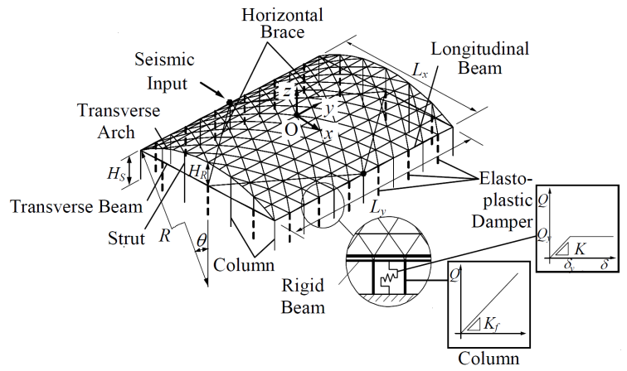

Figure 1: This is a typical figure/photo/table caption [with credits and/or references as appropriate]

# 3. Referencing literature

Cite references by bracketed numbers in the text, as in Winslow *et al.* [1], or Falk and Samulesson [2]. The formats for references of books [3], papers in conference proceedings or special issues [2] and journal papers [1] are exemplified in the 11pt list of references below [Style: References]. Please sort the list of references in the order in which they are cited.

# 4. Conclusion: submission of contributions

Papers should be uploaded to the Symposium submission website by the announced deadline. Submissions should be both .pdf files and MS Word .doc (or .docx) files. We will use the .pdf file in case of technical problems with the MS Word version.

# Acknowledgements

This template was adapted from the one used for IASS-IACM 2008 with modifications modeled after templates for recent IASS annual symposia.

# References

1. P. Winslow, S. Pellegrino and S. B. Sharma, “Mapping two-way grids onto free-form surfaces,” *Journal of the International Association for Shell and Spatial Structures*, vol. 49, pp. 123-130, Aug. 2008.
2. A. Falk and S. Samuelsson, “Timber plates in tensile structures,” in *Shell and Spatial Structures from Models to Realization: Proceedings of the IASS Annual Symposium 2004, Montpellier, France, September 20-24, 2004,* R. Motro Ed., Editions de l’Esperou, 2004. pp. 254-255.
3. M. A. Crisfield, *Non-linear Finite Element Analysis of Solids and Structures. Volume 2: Advanced Topics*. (2nd ed.). New York: Wiley, 1997.